**Looping Statement**

Looping statement are used to execute block of code multiple times.

1. **while loop**

While loop is used to execute block of code multiple times. It will execute same code multiple times until given condition becomes unsatisfied.

**Syntax:**

initialization

while(condition)

{

Block of code

increment / decrement

}

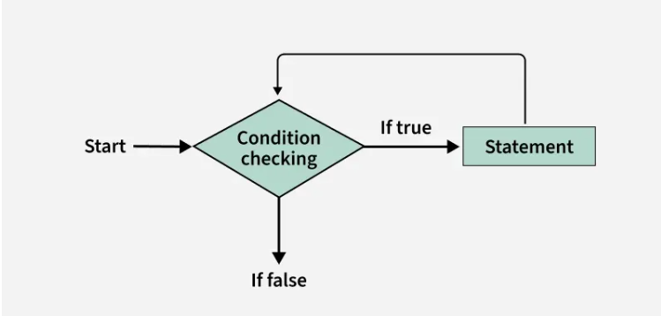

**Example:**

int i = 0;

**while** (i <= 10) {

System.out.print(i + " ");

i++;

}

1. **do-while loop**

do-while loop is used to execute block of code multiple times. It will execute same code multiple times until given condition becomes unsatisfied.

**Syntax:**

Initialization

do

{

Block of code

increment / decrement

}

while(condition)

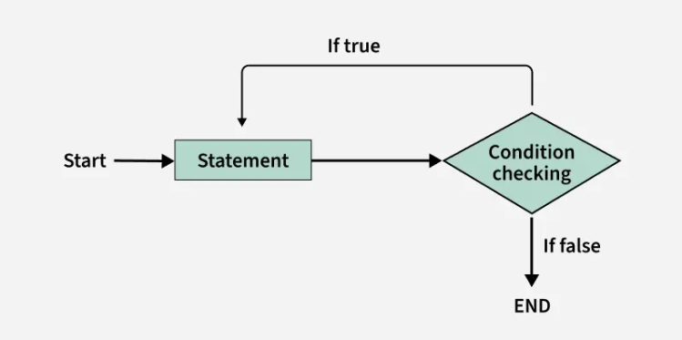

**Example:**

int i = 0;

**do** {

System.out.print (i + " ");

i++;

}

**while** (i <= 10);

1. **for loop**

for loop is used to execute block of code multiple times. It will execute same code multiple times until given condition becomes unsatisfied.

**Syntax:**

for (initialization; condition; increment / decrement )

{

Block of code

}

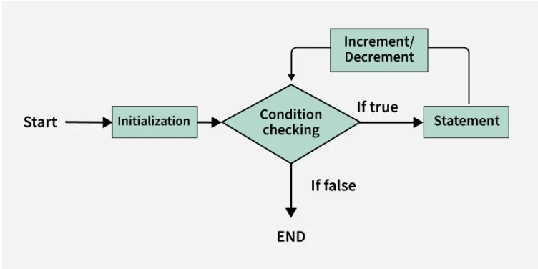

**Example:**

**for** (int i=1; i<=10; i++)

{

System.out.println(i);

}